Nebaioth
Isaiah 60 Prayer Initiative
Nebaioth is included among the nations bringing gifts to adorn God’s temple:
“Herds of camels will cover your land, young camels of Midian and Ephah. And all from Sheba will come, bearing gold and incense and proclaiming the praise of the LORD. All Kedar's flocks will be gathered to you, the rams of Nebaioth will serve you; they will be accepted as offerings on my altar, and I will adorn my glorious temple.”
Isaiah 60:6-7
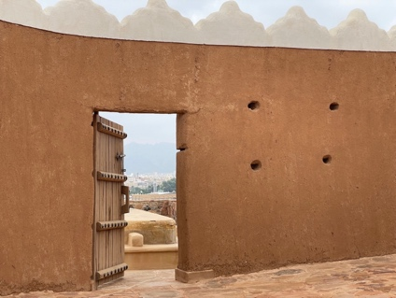
Lord, open the ancient door for the people of Nebaioth to come to You

Day 1
Nebaioth – Background
Although the location of the ancient nation of Nebaioth is not known beyond doubt, ancient Assyrian inscriptions* gives us a clue. From this and other sources, we learn that King Uaite’ of Kedar, ruling from the city of Dumat al-Jandal, fled from Assyrian oppression and war. The Assyrians wanted to control the lucrative trade routes from the southern parts of Arabia (Sheba/Yemen). These accounts describe King Uaite’s journey through a harsh and restrictive desert which was known as the “Nafūd”. Having crossed this desolate and harsh desert, the records say he came to Nebaioth. The present-day city of Ha’il is an oasis at the edge of the desert and seems likely to have been a key city of the nation of Nebaioth to which King Uaite’ fled.
Daniel Luckenbill, Ancient Records of Assyria and Babylonia Volume II, 1927: p 313-321
The mountains of Ha’il provided a natural protective shield for the city. The name, “Ha’il,” means barrier or wall. Any army approaching from the north would also have to cross the desert to attack. The natural protection offered by the mountains and the desert would have made Ha’il the obvious location for the center of life and government for the people of Nebaioth.
The lack of information in Assyrian records about Nebaioth indicates that the Assyrian didn’t concern themselves much with them until they joined military forces with Kedar to rebel against Assyria. Historical evidence indicates that the Assyrian armies crossed, “a parched and thirsty desert where no birds of heaven are seen, where no wild asses or gazelles graze for a long distance.” Assyria did eventually manage to cross this inhospitable desert and they took countless numbers of people, donkeys, camels, and sheep as they conquered Nebaioth, which would have included the area around Ha’il. The amount of plunder taken by the Assyrian army indicates this was a land of plenty. The current area of Ha’il still fits this description, as it is well suited for farming and raising of livestock.
As the last of the worshipping nations listed in Isaiah 60:6-7, Nebaioth is the humblest name on the list. Today Ha’il is a place of blessing, and the people here have an attitude of humility and hospitality toward others. Historically, Ha’il may not have been considered as a strategic or important place for the Assyrians. However, the people of Nebaioth are important to God, as His plans include them and the list of worshipping nations isn’t complete without them!
Mediterranean Sea
Ninevah
Syria
Iran
Iraq
Jordan
Saudi Arabia
Egypt
Babylon
Kufa
Jerusalem
Darb Zubaydah Route
Nafūd / Restrictive Desert
Dumat al-Jandal
Jubbah
Ha’il
Fayd
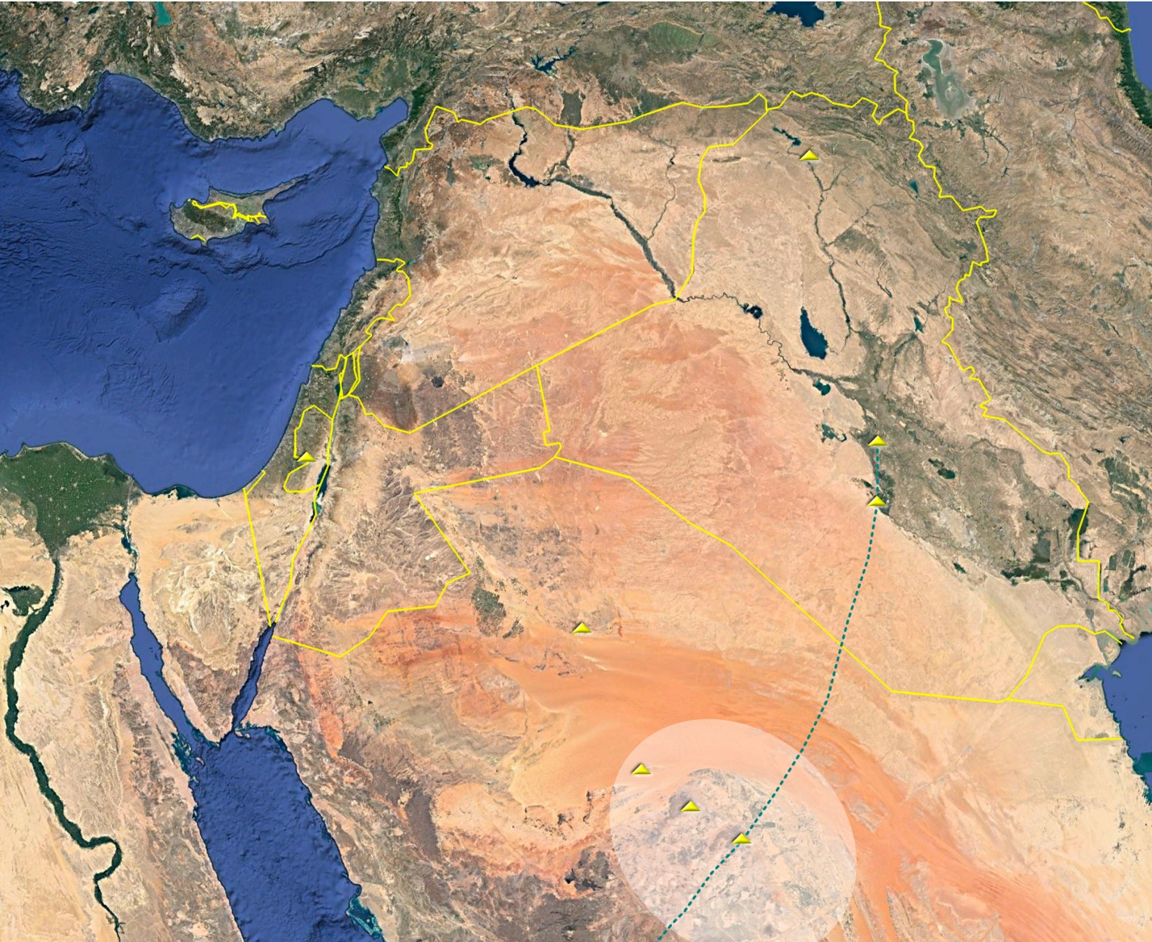
Lord, open the doors to the peoples of Nebaioth into Your Kingdom
Lord, open the ancient doors for the peoples of Nebaioth
Darb Zubaydah Route
Kufa
Bablylon
Euphrates River
Egypt
Mediterranean Sea
Jerusalem
Jordan
Saudi Arabia
Fayd
Há’il
Jubbah
Dumat al-Jandal
Nineveh
Syria
Iran
Nafūd / Restrictive Desert
Tigris River
Iraq

Prayer Points
Pray that from the ancient tribe of Nebaioth many peoples from the Ha’il region of Saudi Arabia will come to the Lord Jesus, and that they will grow in their love of the Lord and desire to bring Him honor.
Pray that the humility of Nebaioth will be part of bringing honor to the Lord.
The Assyrians brought death and destruction on the land of Nebaioth. Pray that the Lord Jesus will bring life and healing to the peoples of Nebaioth.
Islam and materialism are current barriers to the Lord’s work among the families of Nebaioth, not mountains and deserts. Pray for the Lord to remove these barriers that currently are holding people back from knowing Him as Lord and Savior.

Day 2
Nebaioth – What is in a Name?
Ishmael was Abraham’s first son by his wife ‘Hagar,’ the servant given to him by his wife Sarah when they were unable to conceive. Thus, Ishmael’s first son, Nebaioth, is most likely Abraham’s first grandchild.
“And as for Ishmael, I have heard you (Abraham): I will surely bless him; I will make him fruitful and will greatly increase his numbers. He will be the father of twelve rulers, and I will make him into a great nation” Genesis 17:20 NIV.
In the book of Genesis, God tells Abraham that Ishmael will be blessed, fruitful, and the father of 12 rulers. In response Ishmael named his firstborn son Nebaioth, which means “fruitful.” In the Arabic Bible, the word in this verse for “fruitful” is connected to the same root word as Nebaioth, the root word meaning ‘botanical’ or ‘vegetarian’ [نباتي]. The Bible describes the sons of Ishmael moving to the east (Genesis 25:6) and, at a later time, the Assyrian records point to Nebaioth moving to the fruitful region of Ha’il.
Today, as you journey around the area of Ha’il, you will see oases, fields being watered from underground water sources, wheat growing, and agricultural circles at the edge of dry sand dunes. The waters of this area allow for millions of seeds blown into the desert sands to sprout after the early spring rains. When the downpour comes, the desert becomes green with life and the wildflowers blossom.
“The grass withers and the flowers fade, but the word of our God stands forever” (Isaiah 40:8 NLT).
“The desert and the parched land will be glad; the wilderness will rejoice and blossom…” (Isaiah 35:1a NIV).
As the Scriptures say, “People are like grass; their beauty is like a flower in the field. The grass withers and the flower fades. But the word of the Lord remains forever. And that word is the Good News that was preached to you” (1 Peter 1:24–25 NLT).
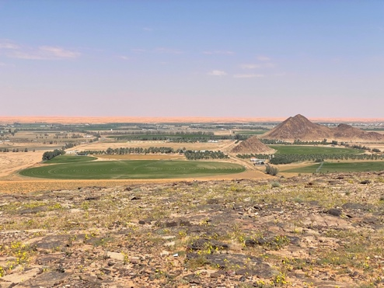
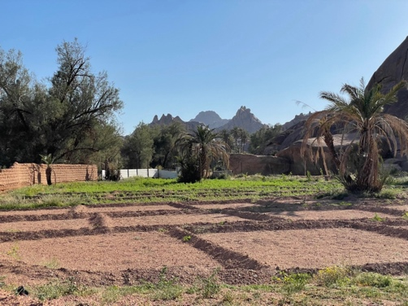

Prayer Points
Ishmael’s life didn’t start with much hope of being fruitful, as he and his mother, Hagar, were exiled into the harsh desert. God protected them and gave them the promise of being fruitful, which gave them hope. Pray that their descendants living in Ha’il recognize that the source of their hope is in the finished work of Jesus on the cross.
Pray that the people of Ha’il will discover the truth of God’s Word through the internet, followers of Jesus in their area, and through dreams and visions. Pray that they will discover God’s eternal love for them as they read the “Good News” of the Bible.
Pray blessing over the farms and businesses of Ha’il and that they will recognize the blessing of fruitfulness comes from the One True God.
Pray that the Lord will reveal Himself to the people of Ha’il and that they will “rejoice and blossom” as worshippers, both now and in the future.

Day 3
Nebaioth – Worship, What Gifts are the People Bringing?
Isaiah 60 speaks of the people of Nebaioth bringing rams, male sheep, as a gift for the altar of the LORD. The Hebrew word for ram is “ail,” denoting strength. This is a promise that the leaders, kings, and people of Nebaioth will bring their gifts to worship the LORD. Their gifts will be symbols of strength and power as a sign of submission to Him, indicating that they recognize Him as the true God and King.
Rams were common animals in ancient Israel along with lambs, goats, and bulls. Rams were often used as various forms of offerings to God:
Rams as a peace offering - Leviticus 9:4
Rams as a burnt offering - Exodus 29:18
Rams as a wave offering - Exodus 29:26
Rams as a guilt offering - Leviticus 5:15
Rams as a fellowship offering - Leviticus 9:18
Rams as a sin offering - 2 Chronicles 29:21
The ram, as well as the bull, are mentioned as suitable sacrifices in Numbers 29, with rams being much more valued than sheep or lambs. The people of Nebaioth will bring their best to the Lord and their worship will be extravagant, a sign that they view Him as more valuable than their possessions and worthy of the best they can offer.
A ram is first mentioned in the Bible in Genesis 15:9 as one of the animals used by God to confirm His covenant with Abraham. Later, God miraculously supplied a ram to Abraham to offer as a sacrifice in place of his son Isaac. The story in Genesis 22, of Abraham’s willingness to sacrifice his own son, is very significant for the Arab people.
A ram caught in the brambles by its horns, which Abraham sees after the angel of the Lord told him not to sacrifice Isaac, becomes the substitute sacrifice for Isaac. This is a foreshadowing of Jesus, the coming Messiah. His sacrifice on the cross made a way for these worshippers to be accepted by the Lord Himself!
The shofar, a trumpet-like instrument used in Hebrew worship, is made from the horn of a ram. The shofar is blown to announce significant moments in Jewish life as well as an announcement in battle. These were the trumpets that were blown as the walls of Jericho fell (Joshua 6:20).
What a symbol the ram is of both the power and worship of the Living God!
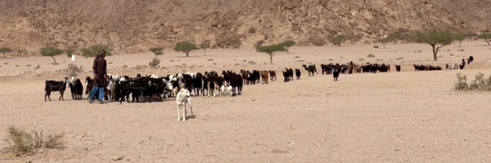

Prayer Points
May the people of Ha’il discover the worth of Jesus now and begin raising their voices in worship in anticipation of the future journey to Jerusalem described in Isaiah 60.
Pray that the story of Abraham will be understood by the people of Ha’il. The story is familiar yet different in Islam. (According to the Islamic tradition Ishmael was the one who was going to be sacrificed.) Pray that this sacrifice that they celebrate each year at Eid Al Adha will be revealed as a picture of what Jesus Christ did for them on the cross.
To be Muslim means to “submit.” Pray that the people of Ha’il will give their best, their lives, and submit to the Lord as King, just as the kings and people of Nebaioth will do in the future.
Pray that the people of Ha’il will understand that Jesus was the only suitable and perfect sacrifice for their sin.
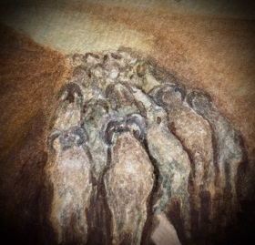

Day 4
Nebaioth – The People of the Land Today
By far the largest tribe in the Ha'il region is the Al Shammari tribe, which is descended from the ancient tribe of Tayy' (some of whom are thought to have been Christian). Shammar means ‘to gird up one's loins’ and we see the Shammari people spiritually “girding up their loins” to mount up for the Isaiah 60 journey. Perhaps you can picture the Al Shammari tribe mounting their camels for the road to Jerusalem bringing the best they have – the rams of Nebaioth as well as their lives as worshippers – as gifts to the LORD.
Another gift that they could bring is hospitality, which is still a key part of the culture in Ha’il. Even today, “Ikrim min Hatim,” (إكرم من حاتم) is a common saying which means, “More generous than Hatim”. In the 6th century, the famous Arab poet, Hatim, was the ruling prince and poet of the Tayy tribe (whose descendants are the Al Shammari). He was said to be the most hospitable and generous person in the world, for which he is honored in Ha’il to this day. In fact, the word ‘welcome’ is displayed in lights, in both Arabic and English, on the mountain where Hatim is said to have built fires to welcome travelers before taking them to his home. He is even mentioned in the famous ‘Arabian Nights’ and is considered a model of Arab culture that many in Ha’il want to try and emulate.
It is said that the Arabs of this area would not lock their doors, for they were living in such a way as to expect travelers and would open their homes to them. This brought honor to the house and those in it, and they would consider it their duty to protect visitors from those who would do them harm. The story of Lot in Genesis 19 reflects this ‘honoring’ of strangers even more than one’s own family.
“Please, my brothers,” he begged, “don’t do such a wicked thing. Look, I have two virgin daughters. Let me bring them out to you, and you can do with them as you wish. But please, leave these men alone, for they are my guests and are under my protection” (Genesis 19:7 NLT).
The Al Shammar people were once a powerful Bedouin tribe, living a nomadic life with herds of camels, sheep, and goats. They were known and admired throughout the Arab peninsula and continue to thrive in the region of Ha’il to this day.

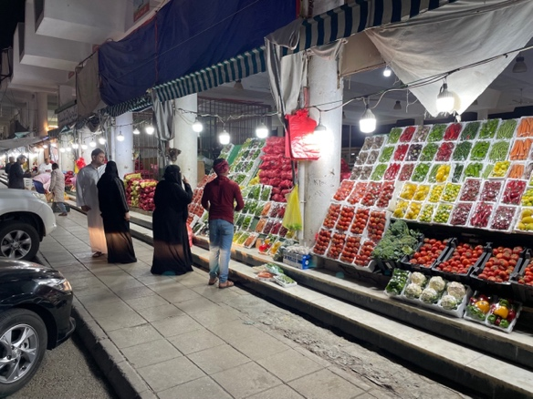

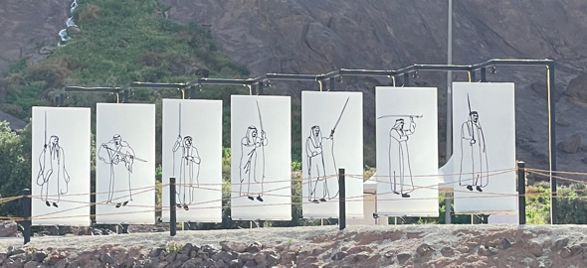

Prayer Points
Pray for the Al Shammar tribe and others living in Ha’il that they will come to understand the greatest gift of all time - salvation - is offered to them through the sacrifice of Jesus on the cross. Pray they will understand they can never repay this gift but will bow in worship as their only response.
Pray that the people will bring this gift of hospitality to the Lord as part of their worship.
Pray that the Christian heritage of the Tayy’ people and others will be revived, and that God will build His church in Ha’il and the surrounding areas.
Pray that the story of Jesus from the Injl (New Testament) will be shared from Ha’il to the nations in the same way the legend of Hatim Al Tayy’ is told throughout the world.

Day 5
Nebaioth – A New Direction and Pilgrimage
Fayd is a village in the region of Ha’il that would have been an important oasis for the people of Nebaioth. A common saying in the Arabian Peninsula is, “Water is life.” Living in a harsh, desert region required finding water in order to survive. Fayd was known as a place of ‘life’ and hosted travelers because it was strategically located on a popular caravan trade route.
In 762 AD, the Abassid Caliphate (the third caliphate in Islamic history) founded the city of Baghdad in Iraq and made it the center of government. One of the most important parts of Islamic life was the pilgrimage to Mecca and Medina for Hajj and a major task for the leaders was to ensure pilgrims could take this difficult journey in safety.
The route between Baghdad and Mecca was called the “Darb Zubaydah.” The “pilgrim road” is 1,935 km, or 1,161 miles long. If you walked 32 km (20 miles) a day, it would take 58 days to walk from Baghdad to Mecca. For almost five centuries, much planning, work, and upkeep went into maintaining this pilgrim road. The oasis of Fayd was the mid-point [منتصف الطريق] (the middle of the road), on the journey between Baghdad and Mecca. This oasis would have provided the pilgrims with a place to rest, safety from attack and freshwater. They might have had high hopes that their sins would be forgiven as they traveled to Mecca, but by the time they returned to Fayd on the homeward journey did they feel the constraints of Islam and sense the inability of the rituals to provide true forgiveness for their own sin?
Today, the ancient oasis of Fayd is desolate and not on any major roads. Once a bustling hub of activity and welcoming landmark for pilgrims headed to Mecca, there are only crumbling ruins and a small museum with a tiny replica of the fortress. There is virtually nothing left of this major part of the overland Zubaydah road. While there are some newer homes due to the presence of freshwater, it is a forgotten place. Fayd was at the most strategic location of the Darb Zubaydah. It attracted pilgrims and merchants who converged on this oasis for many centuries.
However, there is another pilgrimage coming. The Lord is calling for the people of Nebaioth and Fayd to set out upon a new journey. It is a pilgrimage to the Lord Jesus, where their eyes will turn another direction, away from Mecca and toward Jerusalem. The Lord desires for them to bring their lives to Him today and gifts to His temple in the future.
A song for pilgrims ascending to Jerusalem:
Oh, praise the Lord, all you servants of the Lord,
you who serve at night in the house of the Lord.
Lift up holy hands in prayer,
and praise the LORD.
May the Lord, who made heaven and earth,
bless you from Jerusalem.
Psalm 134:1-3
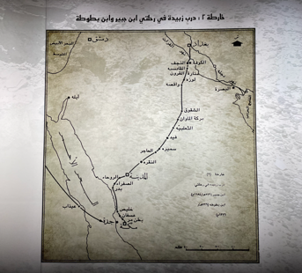
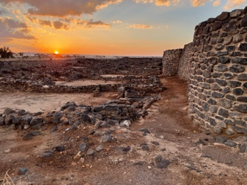

Prayer Points
God has not forgotten Fayd. Pray that the people of Fayd will discover that they are seen and loved by Him.
Pray that the Living Water that Jesus promised will be thirsted for by the people of Ha’il. Pray they will begin seeking it even now.
Pray that the truth of the Gospel will be seen by the people of Nebaioth and that many will put their hope and faith in Jesus.
Each year millions of Muslim pilgrims travel to Mecca with the hope of being cleansed from sin. Each year millions go back home from this pilgrimage empty and disappointed, as the weight of sin cannot be shed by religious practices. Pray that those who come looking for hope will be convicted of their sin and realize they need another answer.
Pray that as pilgrims come to Mecca, God will pour out dreams and visions of Jesus and they will turn their gaze away from darkness and toward life in Him.
Pray that those who are convicted of their sin while on the Mecca pilgrimage will turn their eyes toward Jerusalem and begin a new pilgrimage toward the blessing of the Lord through the Savoir Jesus Christ.

Thank you for praying for Nebaioth. May God bless you for praying for Ha’il and the areas around there. May those for whom we have been praying come to know why we have been praying for them: “For it is all for your sake, so that as grace extends to more and more people it may increase thanksgiving, to the glory of God” (2 Corinthians 4:15 ESV).
Some bolding in the scriptures done to bring emphasis by writer.

